\

Parkview Regional Medical Center

Parkview Hospital Randallia

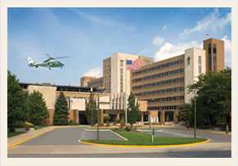

Delete text and place photo here.

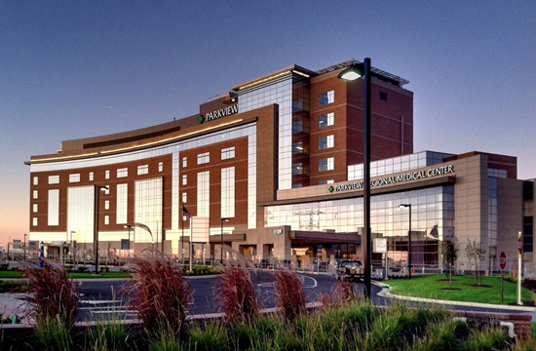

Delete text and place photo here.

Requirements for Application

• Completion of an ACGME or AOA approved Family Medicine residency with a letter from the Program Director documenting training

• ACLS certification, PALS certification and ATLS prior to beginning the program

• American Board of Family Practice certification or eligibility.

• Two letters of recommendation

• Curriculum vitae with recent professional photo

• A letter of intent

• List your services or products here.

#### Emergency Medicine Fellowship



PROFESSIONAL EMERGENCY PHYSICIANS, P.C.

A physician owned Emergency Department group who is currently offering Board-certified/Board-eligible family practice physicians a one–year fellowship opportunity to work alongside Board-certified Emergency physicians in two high-volume emergency departments, including an urban community-based hospital and a tertiary care referral/Level II Trauma center, in order to become well-versed in the care of high acuity patients in the emergency department setting.

FELLOWSHIP DETAILS

A 12-month fellowship comprised of rotating shifts in the emergency department combined with intensive critical care and trauma training focus. The intent is to provide a high-quality educational experience in order to prepare the graduate to work full-time in emergency departments in rural and suburban settings.

Up to 6 positions are offered yearly with a $85,000 stipend per year. Full benefits are offered including liability insurance, health insurance, and disability insurance. Diagnostic and procedural ultrasound, rigorous airway management and critical procedure skills training will be provided. An emphasis in risk management, EM approach to patient care, and case-based training will be seen during the weekly Friday morning didactics. Weekly online Board Review lectures are provided focusing on Core Content EM topics presented in conjunction with attending physicians’ case-based lectures in a “flip the classroom” format to help prepare the fellow to practice in the community hospital Emergency department setting. The fellow will participate in a monthly Journal Club series at EM Grand Rounds.

SUB-HEAD GOES HERE

Continue flyer text here. Continue flyer text here.

Continue flyer text here. Continue flyer text here. Continue flyer text here. Continue flyer text here. Continue flyer text here. Continue flyer text here. Continue flyer text here. Continue flyer text here. Continue flyer text here. Continue flyer text here. Continue flyer text here. Continue flyer text here.

Continue flyer text here. Continue flyer text here. Continue flyer text here. Continue flyer text here. Continue flyer text here. Continue flyer text here.

**Phone:** 260-482-5091

**Fax:** 260-482-5168

608 Union Chapel Rd.  
Fort Wayne, IN 46845

www.professionalemergencyphysicians.com

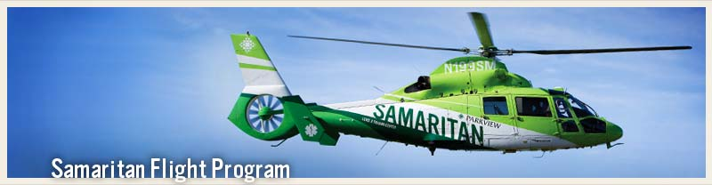

Delete text and place photo here.

Professional Emergency Physicians, P.C.

Fellowship Hospitals

Parkview Regional Medical Center

A state-of-the-art tertiary care referral and Level II trauma center with a 100+ bed emergency department including a Fast Track providing high quality care for high-acuity patients.

Parkview Hospital Randallia

A 65-bed urban setting emergency department with a proactive approach to providing continued health and psychiatric care access to the surrounding community. This includes separate Fast Track and Psychiatric ED assessment units.

THE FACULTY

FELLOWSHIP DIRECTOR:

Tracy R. Rahall, MD, FACEP

FELLOWSHIP INSTRUCTORS:

Nathan Allison, MD, FACEP

Christian Bridgwater, DO, FACEP

Sara Brown, MD, FACEP

Katherine Cassidy, MD, FACEP

Brian Commiskey, DO

Nicholas Gould, DO

Tom Gutwein, MD, FACEP

John Heemstra, MD FACEP

Nathan James, MD FACEP

Tyler Johnson, DO, FACEP

Justin McGee, MD

Rod Morrison, MD, FACEP

Jeff Nickel, MD, FACEP

Michael O’Daniel, MD

Eric Olsen, MD

Sheila Pittenger, MD

Gregg Pollander, FACEP

Courtney Poswinski, MD

Christina Preusz, MD

Justin Ritonya, MD

Joshua Rookus, DO

Corbett Smith, MD, FACEP

Amy Souers, MD

Chris Steffy, MD, FACEP

John Steinhofer, MD

Jared Toupin, MD

Brad Warner, DO

Tom Williman, DO

Scott Wolfe, MD

FORT WAYNE, IN

Fort Wayne is Indiana’s second-largest city and home to over 250,000 residents. The city is the three-time recipient of the All-American City Award and renowned for a quality of life and a low cost of living. It is home to a progressive business climate, solid educational opportunities, affordable living, vibrant entertainment options, and over 400 regional natural lakes perfect for relaxing getaways and abundant outdoor recreational opportunities.



#### EMERGENCY MEDICINE FELLOWSHIP